[How to Setup Web Server with live Domain Name in XAMPP - YouTube](https://www.youtube.com/watch?v=UMGNxHvbb84)

<em> italic

<strong> bold

<br> line breaks

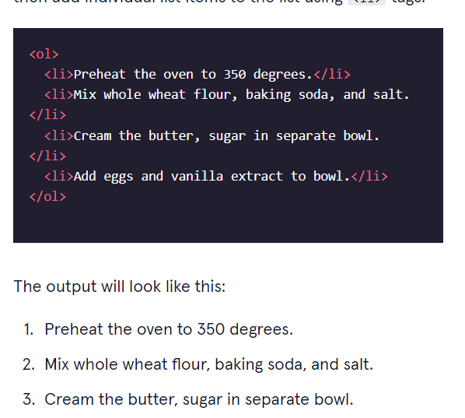

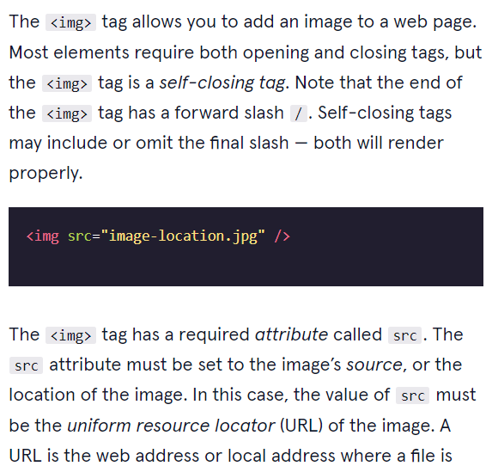

<ul>

Unordered list

* A
* b

<body>

  <h1>The Brown Bear</h1>

  <div id="introduction">

    <h2>About Brown Bears</h2>

    <p>The brown bear (<em>Ursus arctos</em>) is native to parts of northern Eurasia and North America. Its conservation status is currently <strong>Least Concern</strong>.<br /><br /> There are many subspecies within the brown bear species, including the Atlas bear and the Himalayan brown bear.</p>

    <h3>Species</h3>

    <ul>

      <li>Arctos</li>

      <li>Collarus</li>

      <li>Horribilis</li>

      <li>Nelsoni (extinct)</li>

    </ul>

    <h3>Features</h3>

    <p>Brown bears are not always completely brown. Some can be reddish or yellowish. They have very large, curved claws and huge paws. Male brown bears are often 30% larger than female brown bears. They can range from 5 feet to 9 feet from head to toe.</p>

  </div>

  <div id="habitat">

    <h2>Habitat</h2>

    <h3>Countries with Large Brown Bear Populations</h3>

    <ol>

      <li>Russia</li>

      <li>United States</li>

      <li>Canada</li>

    </ol>

    <h3>Countries with Small Brown Bear Populations</h3>

    <p>Some countries with smaller brown bear populations include Armenia, Belarus, Bulgaria, China, Finland, France, Greece, India, Japan, Nepal, Poland, Romania, Slovenia, Turkmenistan, and Uzbekistan.</p>

  </div>

  <div id="media">

    <h2>Media</h2>

    <img src="https://content.codecademy.com/courses/web-101/web101-image_brownbear.jpg" alt="A Brown Bear"/> <br>

    <video src ="https://content.codecademy.com/courses/freelance-1/unit-1/lesson-2/htmlcss1-vid_brown-bear.mp4" width ="320" height ="240"  controls>Video not supported

    </video>

  </div>

</body>

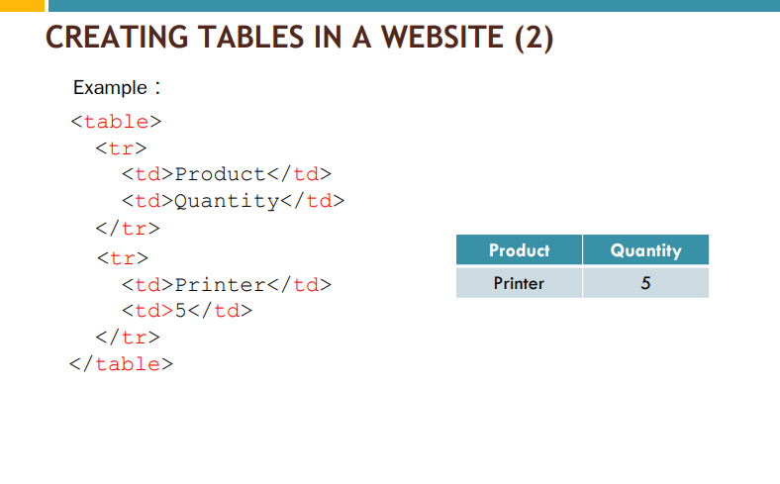

<!DOCTYPE html>

<html>

<head>

  <title>Brown Bears</title>

</head>

<body>

  <a href="./index.html">Brown Bear</a>

  <a href="./aboutme.html">About Me</a>

  <h1>The Brown Bear</h1>

  <ul>

<li><a href="#introduction">Introduction<a/> </li>

<li><a href="#habitat">Habitat</a></li>

<li><a href="#media">Media</a></li>

    </ul>

  <div id="introduction">

    <h2>About Brown Bears</h2>

    <p>The brown bear (<em>Ursus arctos</em>) is native to parts of northern Eurasia and North America. Its conservation status is currently <strong>Least Concern</strong>.<br /><br /> There are many subspecies within the brown bear species, including the

      Atlas bear and the Himalayan brown bear.</p>

    <a href="https://en.wikipedia.org/wiki/Brown_bear" target="_blank">Learn More</a>

    <h3>Species</h3>

    <ul>

      <li>Arctos</li>

      <li>Collarus</li>

      <li>Horribilis</li>

      <li>Nelsoni (extinct)</li>

    </ul>

    <h3>Features</h3>

    <p>Brown bears are not always completely brown. Some can be reddish or yellowish. They have very large, curved claws and huge paws. Male brown bears are often 30% larger than female brown bears. They can range from 5 feet to 9 feet from head to toe.</p>

  </div>

  <div id="habitat">

    <h2>Habitat</h2>

    <h3>Countries with Large Brown Bear Populations</h3>

    <ol>

      <li>Russia</li>

      <li>United States</li>

      <li>Canada</li>

    </ol>

    <h3>Countries with Small Brown Bear Populations</h3>

    <p>Some countries with smaller brown bear populations include Armenia, Belarus, Bulgaria, China, Finland, France, Greece, India, Japan, Nepal, Poland, Romania, Slovenia, Turkmenistan, and Uzbekistan.</p>

  </div>

  <div id="media">

    <h2>Media</h2>

    <a href="https://en.wikipedia.org/wiki/Brown_bear" target="_blank"><img src="https://content.codecademy.com/courses/web-101/web101-image_brownbear.jpg"/></a>

    <video src="https://content.codecademy.com/courses/freelance-1/unit-1/lesson-2/htmlcss1-vid_brown-bear.mp4" height="240" width="320" controls>Video not supported</video>

  </div>

</body>

</html>

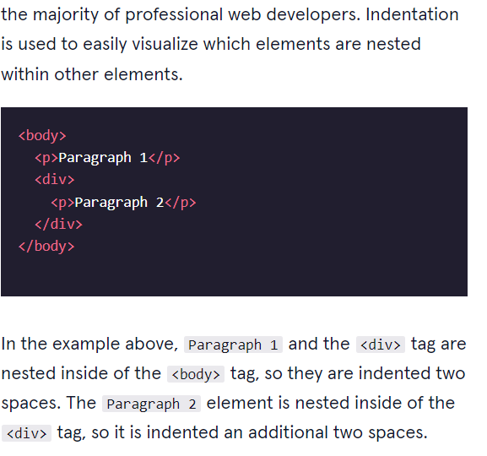

COMMENT OUT

Let’s review what you’ve learned this lesson:

1. The <!DOCTYPE html> declaration should always be the first line of code in your HTML files. This lets the browser know what version of HTML to expect.
2. The <html> element will contain all of your HTML code.
3. Information about the web page, like the title, belongs within the <head> of the page.
4. You can add a title to your web page by using the <title> element, inside of the head.
5. A webpage’s title appears in a browser’s tab.
6. Anchor tags (<a>) are used to link to internal pages, external pages or content on the same page.
7. You can create sections on a webpage and jump to them using <a> tags and adding ids to the elements you wish to jump to.
8. Whitespace between HTML elements helps make code easier to read while not changing how elements appear in the browser.
9. Indentation also helps make code easier to read. It makes parent-child relationships visible.
10. Comments are written in HTML using the following syntax: <!-- comment -->.